Formulate a clear hypothesis about your data:

Some context:
Plants have a systemic immune response called systemic acquired resistance (SAR). This response is described as the priming of uninfected distant leaves for defense following a localized infection. In the lab, we assess SAR by measuring the bacterial level in distant leaves following a mock- (MgCl₂) or SAR- (Pseudomonas syringae pv. tomoto avrRpt2) induction. We expect for a SAR-competent plant a significant reduction in bacterial multiplication in SAR-induced vs. mock-induced plants, at least a 10-fold reduction for a typical/biologically significant response.

Hypotheses:
The NHP-biosynthesis mutants, fmo1-1 and ald1-T2, are defective for SAR

The NHP-biosynthesis mutants, fmo1-1 and ald1-T2, have local resistance* defects

*The assay is designed to monitor SAR; we can infer local defects from the mock levels, but we would need to directly test local resistance before we can conclude anything biologically significant.

Objectives:
Determine if a clear reduction in bacterial multiplication can be observed for mock vs. SAR-induced fmo1-1 or ald1-T2 plants

Determine if fmo1-1 or ald1-T2 displays a clear defect in local defenses by looking at the bacterial level in mock-induced plants

Linear Model

lm_int <- lm(population ~ treatment*genotype, data = log_data))

> summary(lm_int)

Call:
lm(formula = population ~ treatment * genotype, data = log_data)

Residuals:
Min 1Q Median 3Q Max
-0.055982 -0.016510 -0.000993 0.020768 0.042121

Coefficients:
Estimate Std. Error t value Pr(>|t|)
(Intercept) 6.71375 0.01247 538.606 <2e-16 ***
treatmentSAR -0.62839 0.01763 -35.647 <2e-16 ***
genotypefmo1-1 0.03172 0.01763 1.800 0.082 .
genotypeald1-T2 0.01916 0.01763 1.087 0.286
treatmentSAR:genotypefmo1-1 0.65546 0.02493 26.292 <2e-16 ***
treatmentSAR:genotypeald1-T2 0.61693 0.02493 24.746 <2e-16 ***
---
Signif. codes: 0 ‘***’ 0.001 ‘**’ 0.01 ‘*’ 0.05 ‘.’ 0.1 ‘ ’ 1

Residual standard error: 0.03053 on 30 degrees of freedom
Multiple R-squared: 0.9871, Adjusted R-squared: 0.9849
F-statistic: 458.5 on 5 and 30 DF, p-value: < 2.2e-16

Equation:
log10(Population (cfu/ld) = 6.71375 +
-0.62838[treatmentSAR] +
+0.03172[genotypefmo1-1] +
+0.01916[genotypeald1-T2] +
+0.65546[treatmentSAR:genotypefmo1-1] +
+0.61693[treatmentSAR:genotypeald1-T2] +
E

Diagnostic Plot
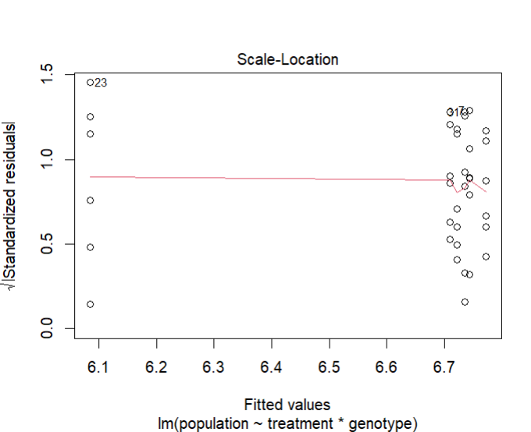

This is the Scale-Location plot generated from the data used for fitting my linear model. The purpose of this plot is to assess the homogeneity of variance, which is an assumption linear models. To meet this assumption, the line should be roughly horizontal with no clear pattern among the residuals to indicate that the assumption is reasonably met. Since the line in my plot is reasonably flat, and there is no clear pattern of distribution in the residuals across the line, I consider the assumption of homoscedasticity met.

The uneven distribution of points along the x-axis was stood out to me, since examples of these scale-location plots I have seen have a more continuous distribution across the x-axis. In my plot, the residuals are clustered at the two ends of the figure. I believe this clustering is a consequence of using two categorical predictors in the model, so fitted values are based on the group means. Since this is SAR assay data, the group means for mock- and SAR-induced plants tend to be similar, around 6x10⁶-1x10⁷ for mock-induced, and at least 10-fold less for SAR-induced. Since there are SAR-defective genotypes included in the data, this would create this clustering towards the right end of the plot. Therefore, this does not appear to be anything concerning and simply a quirk of the type of data being used.

Prediction Plot
I plotted emmeans two ways for the prediction plot, the way shown in class and a ggplot way that I find a bit easier to interpret.

library(emmeans)

plot(emmeans(lm_int, ~genotype*treatment), comparison = TRUE)
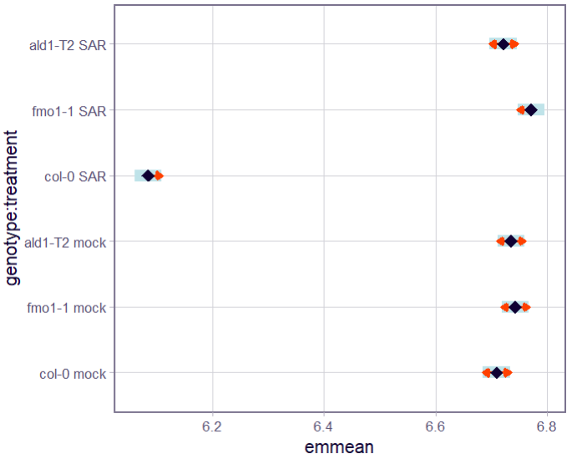
This plot shows the estimated marginal means for each genotype x treatment combination in my linear model. The red arrows represent 83.3% non-overlap intervals (Knol et al., 2011). These are constructed so that non-overlap corresponds to statistically clear differences of the estimated means, at an α = 0.05, while overlap indicates the difference is statistically unclear.

Using these intervals, it is statistically clear that Col-0 x SAR has a much lower predicted bacterial level than Col-0 x mock, which is expected of a SAR-responding genotype. In contrast, a difference is unclear for both fmo1-1 and ald1-T2 between the mock and SAR combinations, as they have overlapping intervals. This suggests there is a SAR-defective phenotype for these mutants. When comparing Col-0 to the other genotypes within the mock treatment, differences are statistically unclear. This suggests the genotypes may exhibit a similar level of local resistance, but this should be more directly investigated with a local resistance assay before any conclusions about biological significance can be made.

Prediction Plot + ggplot2
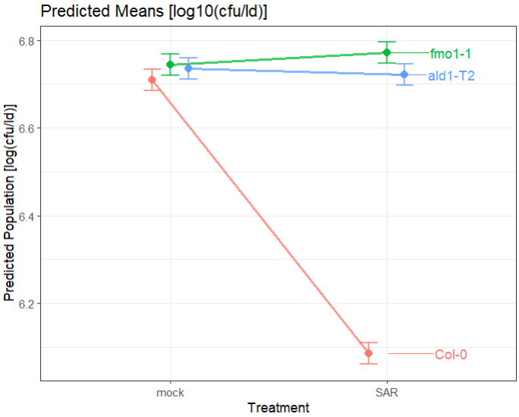
This plot shows the same data as the previous plot, with only 95% confidence intervals. I believe this more clearly demonstrates the SAR-defective phenotype of fmo1-1 and ald1-T2 plants through the model-predicted means.

Inference Plot
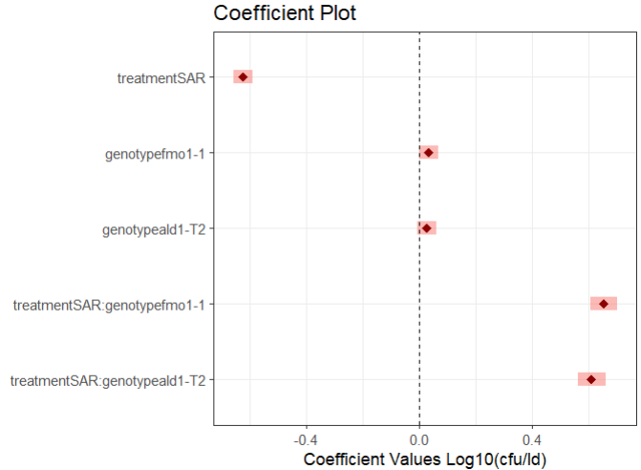
This coefficient plot was generated from dwplot() and modified with additional ggplot2 arguments. The plot displays estimated coefficients from the linear model with 95% confidence intervals. The coefficients for genotypefmo1-1 and genotypeald1-T2 both have confidence intervals that overlap zero, indicating that, relative to the reference condition (Col-0 x mock). The main effects of genotype are small and statistically unclear.

The coefficient for treatmentSAR is strongly negative, suggesting that SAR induction substantially reduces bacterial levels when genotype is held constant (Col-0). The interaction terms (genotypefmo1-1:treatmentSAR and genotypeald1-T2:treatmentSAR) are large and positive. These positive effects counteract the large negative effect of treatmentSAR when the genotype is either fmo1-1 or ald1-T2. This indicates that SAR treatment does not reduce bacterial levels in fmo1-1 or ald1-T2 to the same extent as in Col-0. Based on the magnitude of the positive effect, it appears the SAR effect is nearly completely abolished in these mutants.

From this coefficient plot, I can infer that:
- In Col-0 plants, SAR induction has a strong negative effect on bacterial levels
- In mock-treated plants, the difference in genotype (i.e., fmo1-1 and ald1-T2 ) does not have a strong or clear effect on bacterial levels.
- In fmo1-1 and ald1-T2 plants, SAR induction has a greatly diminished effect on bacterial level.

